Project Title
World-Level-Plagiarism-Detection-for-Small-Documents
Project Report submitted for the partial fulfilment of grade for the course

Data Structures and Algorithms - 3 (25CS2103E)
in

A.Y. 2026-2027

Submitted by
Devaji Rashmika(2520090152)
Allamsetti Lahari (2520090004)
Team Number: 28
Section: 12

Under the guidance of
Dr. Chandusha
Assistant Professor ,CSIT


Hyderabad-500090, Telangana, India.

K L (Deemed to be) University
DEPARTMENT OF COMPUTER SCIENCE ENGINEERING / COMPUTER SCIENCE AND INFORMATION TECHNOLOGY/ARTIFICIAL INTELLIGENCE & DATA SCIENCE



DECLARATION

The Mini Project Report entitled “World-Level-Plagiarism-Detection-for-Small-Documents
” is a record of Bonafide work of Devaji Rashmika-2520090152, Allamsetti Lahari-2520090004 submitted in partial fulfillment for the award of B. Tech in Computer Science and Engineering/Computer Science and Information Technology/ Artifical Intelligence & data Science to the K L University. The results embodied in this report have not been copied from any other departments/University/Institute.

Devaji Rashmika – 2520090152
Allamsetti Lahari-2520090004

K L (Deemed to be) University
DEPARTMENT OF COMPUTER SCIENCE ENGINEERING / COMPUTER SCIENCE AND INFORMATION TECHNOLOGY
CERTIFICATE

This is to certify that the mini project based report entitled “World-Level-Plagiarism-Detection-for-Small-Documents” is a Bonafide work done and submitted by Devaji Rashmika-2520090152, Allamsetti Lahari-2520090004 in partial fulfillment of the requirements for the award of the degree of BACHELOR OF TECHNOLOGY in Department of Computer Science Engineering/ Computer Science and Information Technology/Artificial Intelligence & Data Science, K L (Deemed to be University), during the academic year 2026-2027.

Signature of the Supervisor

Signature of the HOD Signature of the External Examiner

ACKNOWLEDGEMENT

The success in this project would not have been possible but for the timely help and guidance rendered by many people. Our wish to express my sincere thanks to all those who has assisted us in one way or the other for the completion of my project.

Our greatest appreciation to my guide, Dr.Chandusha, Assistant.Professor, CSIT which cannot be expressed in words for his/her tremendous support, encouragement and guidance for this project.

We express our gratitude to Dr. P.Venkateshwar Rao (CSE)/Dr. Khaja Shareef (CSIT)/ Dr. Sreenath Itikela (AI&DS), Head of the Department for Computer Science Engineering/ Department for Computer Science and Information Technology/Department of Artificial Intelligence and Data Science for providing us with adequate facilities, ways and means by which we are able to complete this project-based Lab.

We thank all the members of teaching and non-teaching staff members, and also who have assisted me directly or indirectly for successful completion of this project. Finally, I sincerely thank my parents, friends and classmates for their kind help and cooperation during my work.

Devaji Rashmika-2520090152
Allamsetti Lahari-2520090004

TABLE OF CONTENTS

S.No. | Contents | Page no.
1. | Abstract | 6
2. | Introduction | 7
3. | Literature survey | 8
4. | Problem Statement and Objectives | 10
5. | Hardware and Software requirements | 11
6. | Implementation | 12
7. | Results & Discussion | 13
8. | Conclusion & Future Scope | 17
9. | References | 17

1.ABSTRACT

Plagiarism detection is an important requirement in academic, professional, and digital environments, where identifying copied content helps maintain originality and content integrity. Manually comparing documents to find duplicated words and phrases can be time-consuming and difficult, particularly when multiple documents need to be analyzed. This project focuses on developing a word-level plagiarism detection system for short documents that automatically identifies matching content between documents.
The proposed system analyzes the textual content of the given documents and compares their words and phrases to detect similarities. It identifies matching portions and highlights the copied or similar content, allowing users to easily understand where plagiarism may have occurred. The system focuses specifically on word-level matching, making it suitable for short documents such as assignments, reports, notes, and other textual submissions.
The main objective of the system is to provide a simple, fast, and reliable method for detecting plagiarism without requiring extensive manual comparison. By automating the comparison process, the system reduces human effort and improves the efficiency of plagiarism identification. The proposed solution can serve as a useful tool for students, educators, and content reviewers to check the originality of short textual documents.
Team Name: 28

Team Members:
- Devaji Rasnmika,2520090152
- Allamsetti Lahari, 2520090004

- INTRODUCTION

Plagiarism is the act of copying or using another person’s words, ideas, or written content without proper acknowledgement. With the increasing use of digital documents, identifying copied content has become important in academic, professional, and content-writing environments. Manually comparing documents to find similar words and phrases can be time-consuming and may lead to errors. Therefore, an automated plagiarism detection system can help users quickly identify similarities between documents.

The proposed Word-Level Plagiarism Detection System focuses on detecting copied or matching words and phrases in short documents. The system compares the content of two or more documents, identifies common words or sequences, and calculates their similarity percentage. It provides a simple and efficient way to evaluate the originality of a document and helps users locate potentially plagiarized content. The project aims to provide a lightweight and user-friendly solution for detecting plagiarism in short textual documents.

- LITERATURE SURVEY
1. Turnitin
Turnitin is a widely used plagiarism detection system for academic documents. It compares submitted documents with a large collection of web pages, academic papers, and previously submitted documents. It generates a similarity report highlighting matching content. The system is mainly designed for educational institutions and academic integrity.
2. Grammarly Plagiarism Checker
Grammarly provides a plagiarism-checking feature that compares written content against publicly available web pages. It identifies potentially matching text and helps users improve the originality of their writing. The tool is integrated with its writing-assistance features and is commonly used for essays, articles, and other documents.
3. Quetext
Quetext is an online plagiarism detection platform that analyzes text and searches for similar content. It highlights matching phrases and provides a similarity report. Its simple interface allows users to paste or upload content for plagiarism checking.
4. Copyscape
Copyscape is an online plagiarism detection service primarily used to identify duplicate web content. It compares submitted text with online sources and reports pages containing similar content. It is particularly useful for bloggers, website owners, and content creators.
5. SmallSEOTools Plagiarism Checker
SmallSEOTools provides a web-based plagiarism checker that compares submitted text with content available online. It identifies duplicate or similar sentences and provides a percentage-based plagiarism result. The tool is commonly used for quick content verification.
6. DupliChecker
DupliChecker is an online plagiarism detection tool that allows users to check text for duplicate content. It compares the submitted content with online sources and displays matching or similar text. The platform is designed to provide a quick and accessible plagiarism-checking solution.

7. PlagScan
PlagScan is a plagiarism detection solution that compares documents against online sources and other document databases. It provides similarity reports and highlights potentially copied sections. It is mainly intended for academic and professional use.
8. Unicheck
Unicheck is a plagiarism detection platform designed for educational and professional environments. It checks documents for similarities against internet sources and other available content. The system provides reports that help users identify and review potentially plagiarized sections.

- Problem Statement and Objectives

Problem Statement
The proposed system aims to develop an automated word-level plagiarism detection system for short documents. The system identifies identical or closely matching words and phrases between two or more documents and determines the extent of copied content.
The system is designed to provide a simple and efficient way to detect plagiarism without requiring manual comparison. By analyzing the textual content and identifying matching portions, it helps users quickly understand whether a document contains copied material from another document.

Problem Description
Manually comparing short documents to identify copied words or phrases can be time-consuming and prone to human error. Even when documents are relatively small, finding repeated or matching content manually can be difficult, especially when multiple documents need to be compared.
The proposed system automates this process by comparing the contents of documents and identifying matching words and phrases. It highlights the detected similarities and provides a clear indication of the copied content, making plagiarism detection faster, easier, and more reliable.

Objectives
- To develop a simple word-level plagiarism detection system.
- To compare the contents of short documents efficiently.
- To identify matching words and phrases.
- To calculate the similarity percentage between documents.
- To highlight potentially plagiarized content.
- To provide an easy-to-understand plagiarism result.

- HARDWARE AND SOFTWARE REQUIREMENTS
Hardware Requirements
- Computer/Laptop
- Minimum 4 GB RAM
- Intel Core i3 processor or equivalent
- Minimum 500 MB free storage
Software Requirements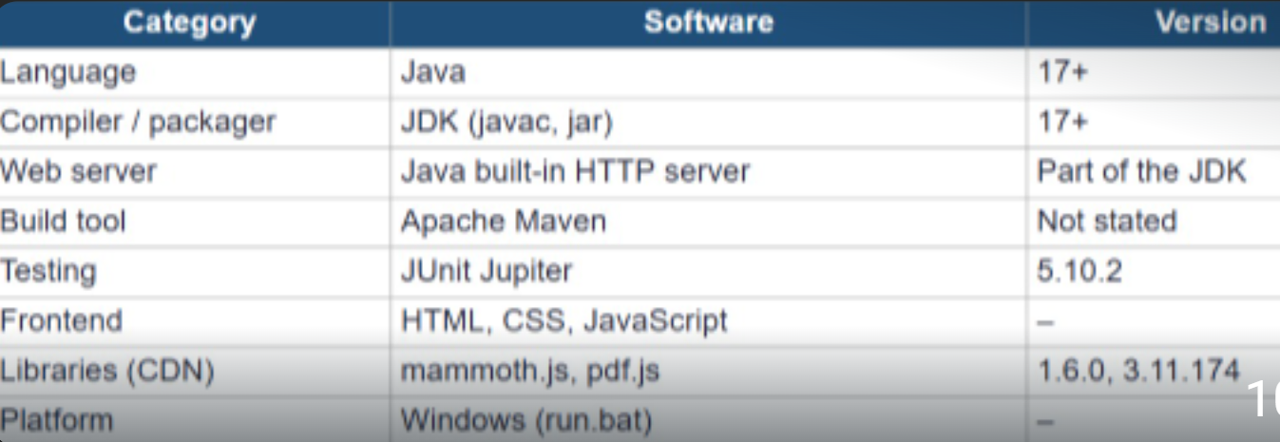

- IMPLEMENTATION

Module 1 – Document Input
This module accepts the text or short documents provided by the user. It prepares the input for further processing and comparison.
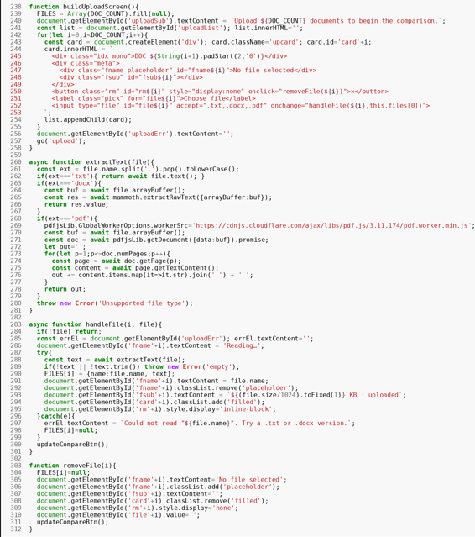
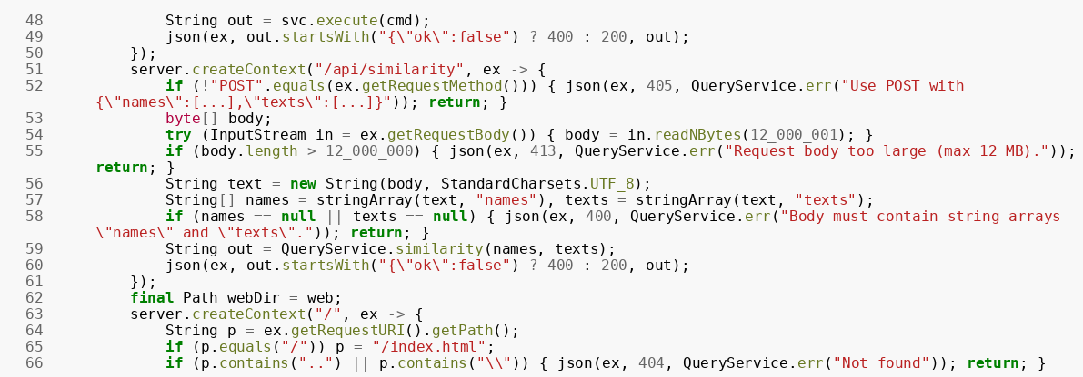

Module 2 – Text Preprocessing
The text is cleaned and processed by converting it into a suitable format. Unnecessary characters and spaces can be removed to improve comparison accuracy.
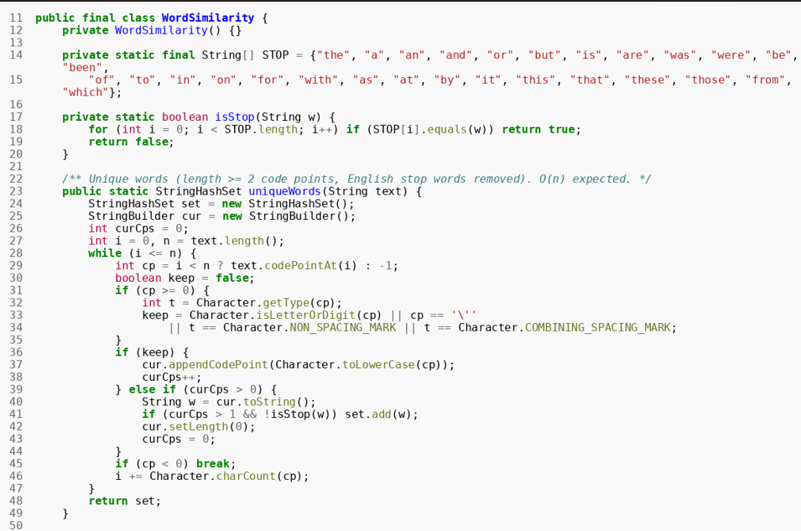
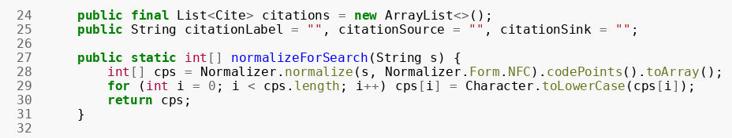

Module 3 – Word-Level Comparison
This module compares the words and phrases present in the documents. Matching words are identified and used to determine the similarity between the documents.
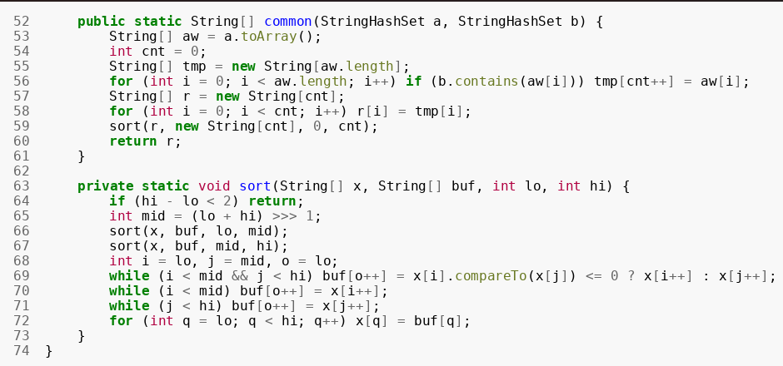
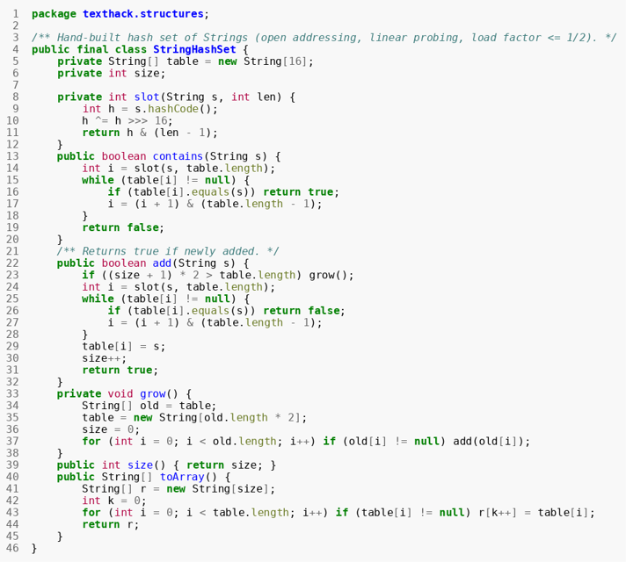
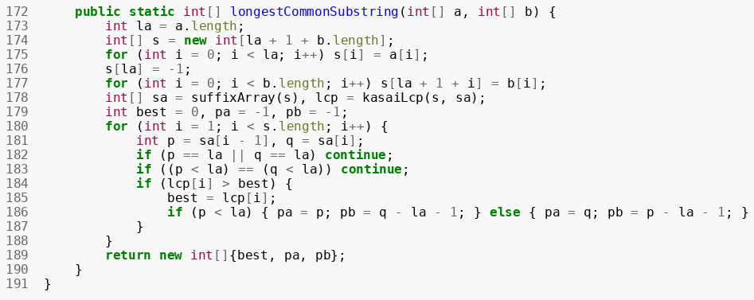

Module 4 – Plagiarism Result
The system calculates the similarity percentage and displays the plagiarism result. Matching content can also be highlighted to help the user understand which parts are similar.
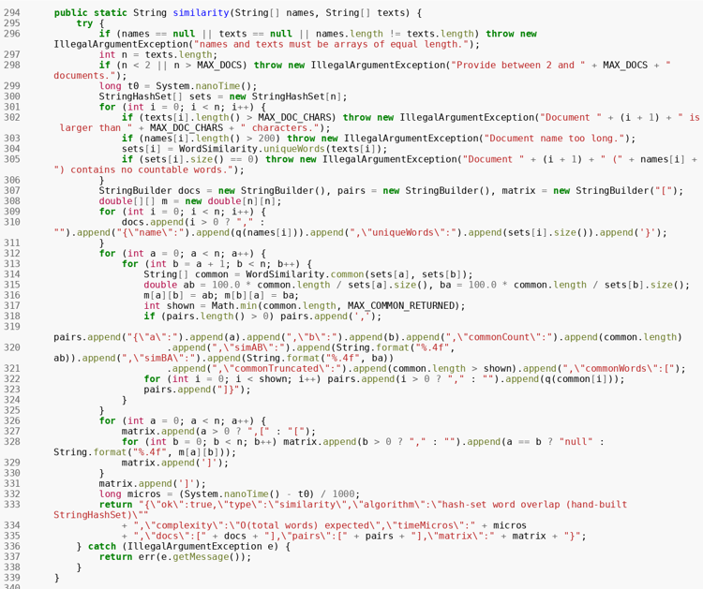
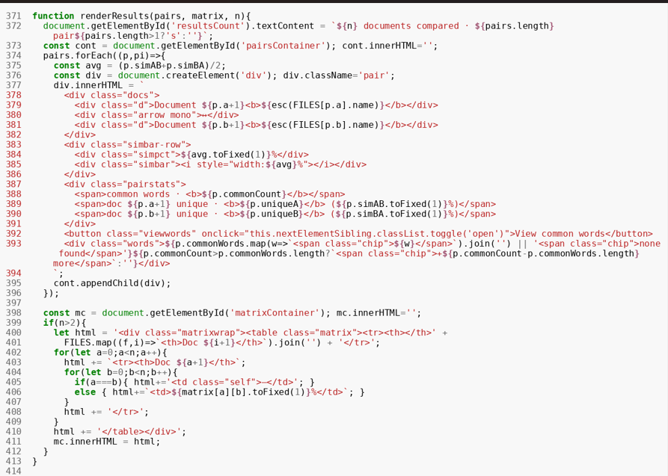
- RESULTS & DISCUSSION
Output 1 – Document Input
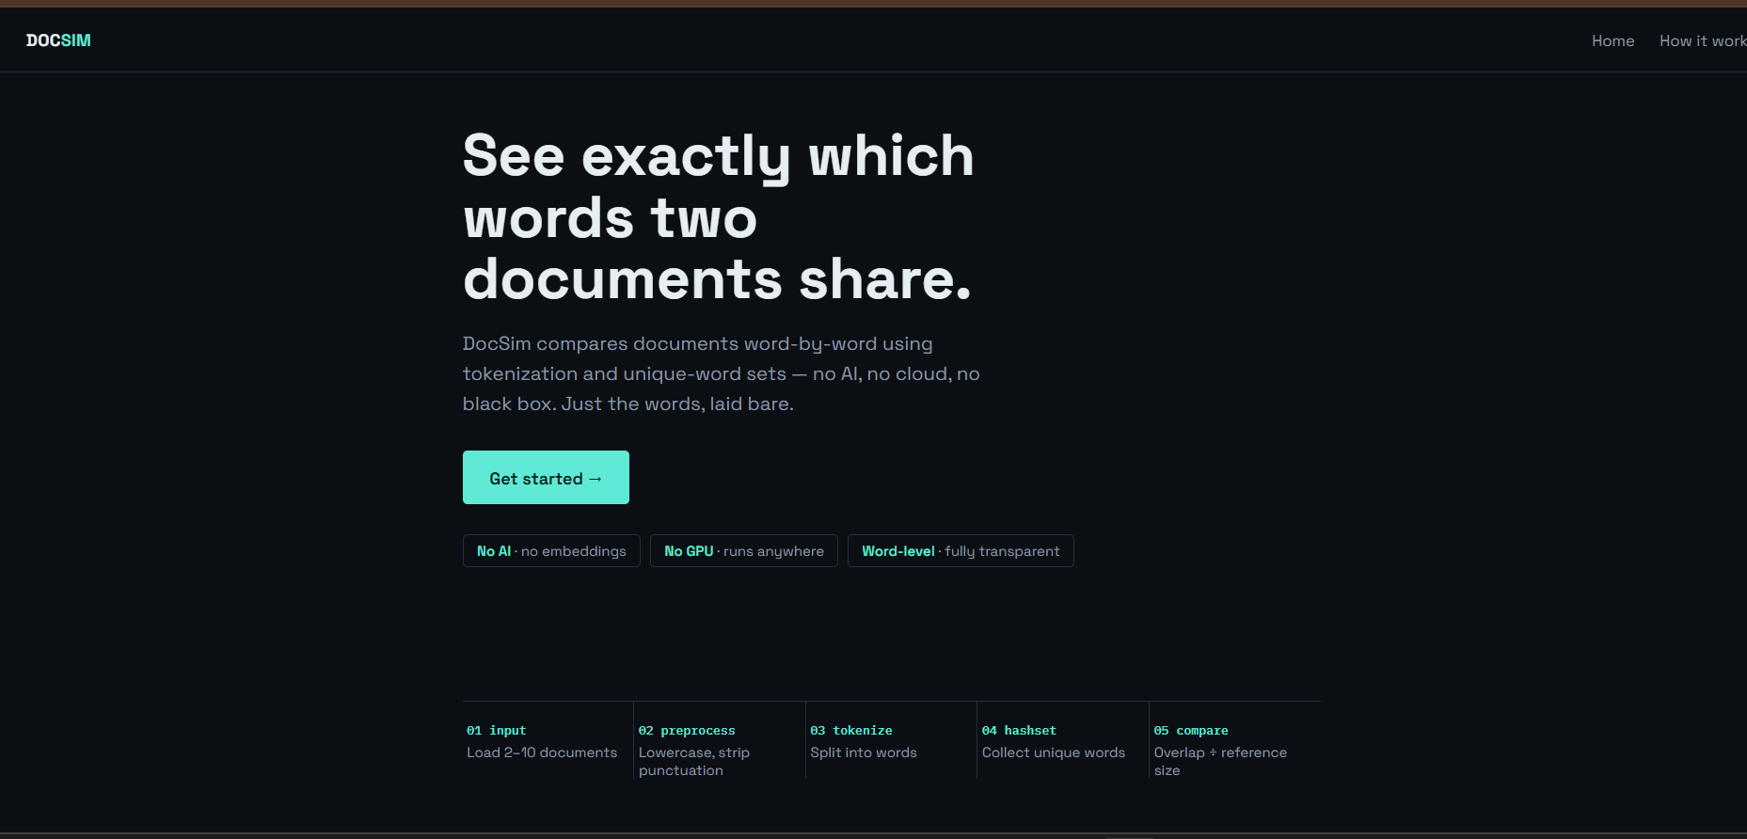
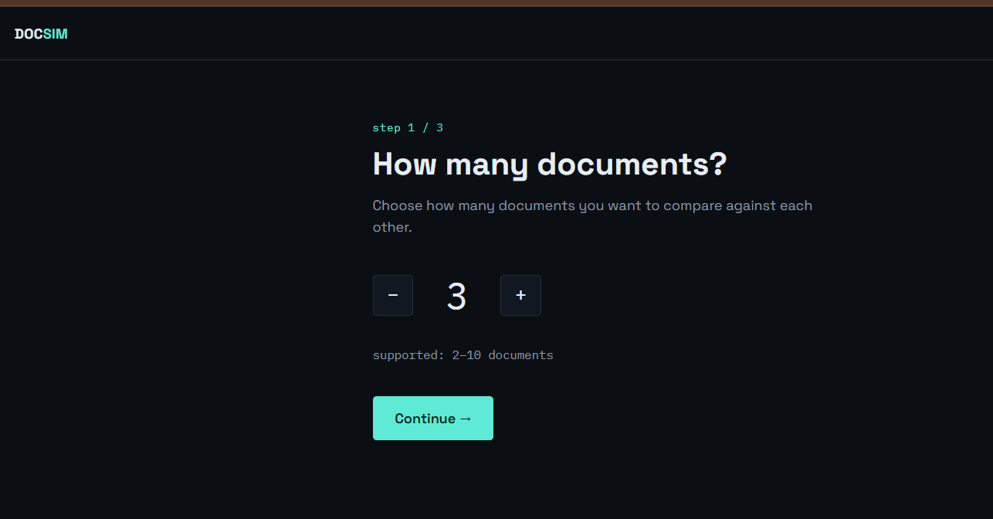

The application allows the user to enter or upload short documents that need to be checked for plagiarism.

Output 2 – Text Comparison
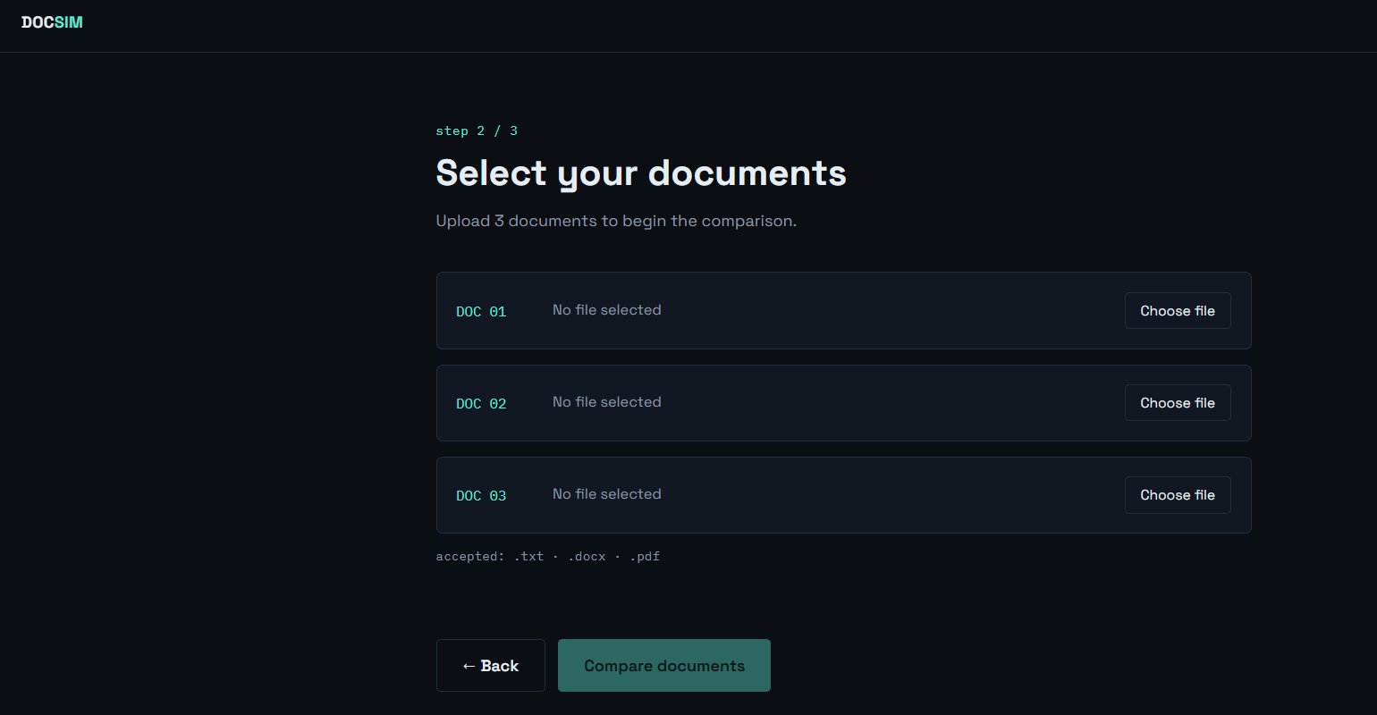
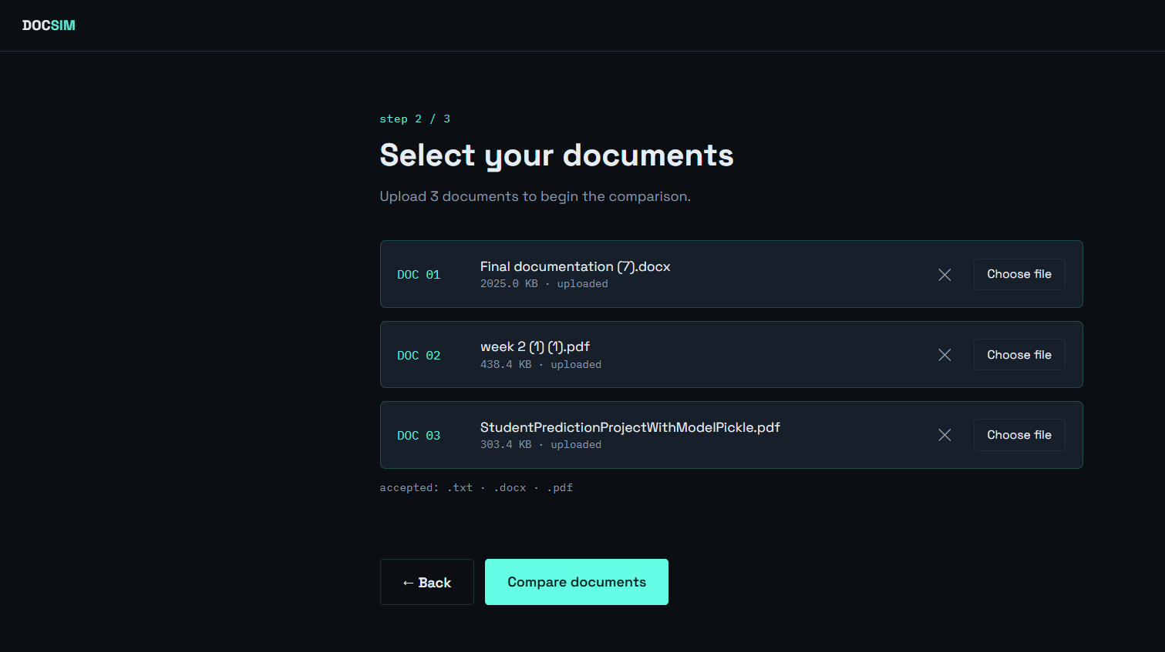

The system processes the input documents and compares their words and phrases to identify matching content.

Output 3 – Matching Content
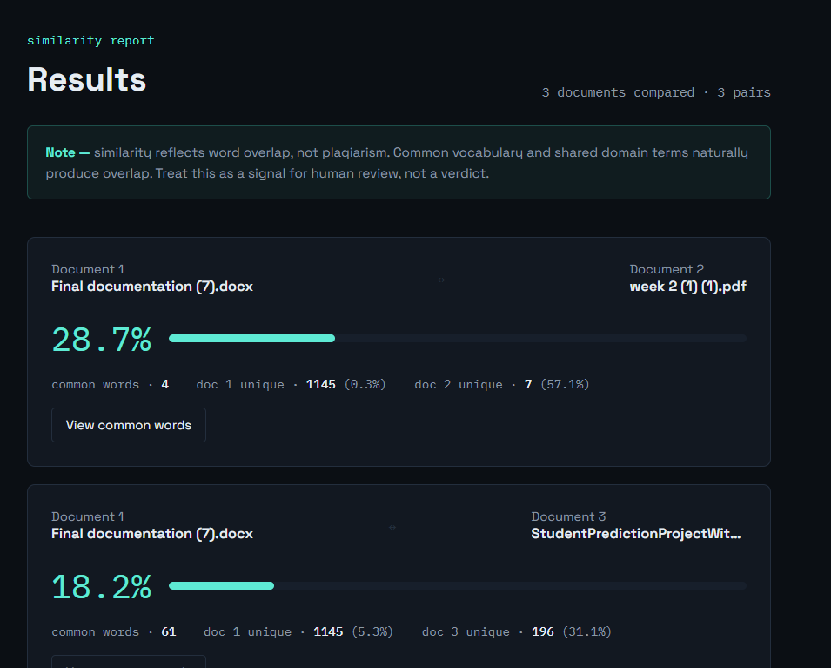

The application highlights or displays the words/phrases that are common between the documents.

Output 4 – Similarity Result
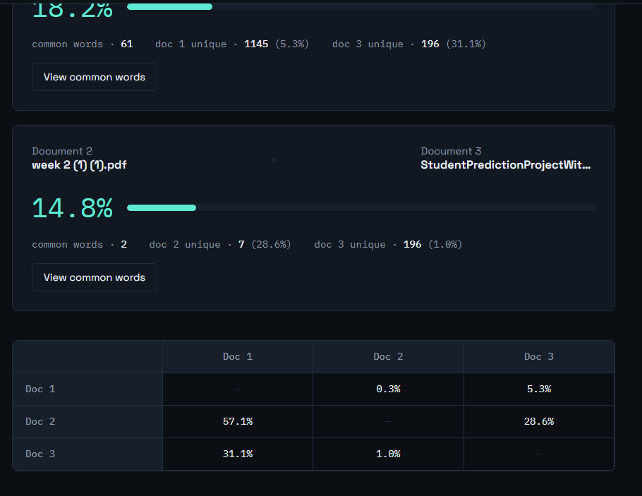

The final result displays the similarity or plagiarism percentage, allowing the user to determine the level of duplicated content.

- CONCLUSION & FUTURE SCOPE

The Word-Level Plagiarism Detection system provides a simple and efficient method for identifying similarities in short documents. The project successfully compares document content, detects matching words and phrases, and provides a similarity result. It reduces the effort required for manual comparison and helps users evaluate the originality of their content.

The system can be further improved by supporting longer documents and multiple file formats such as PDF and DOCX. Advanced Natural Language Processing techniques can be incorporated to detect paraphrased and semantically similar content. Future versions can also include a larger database of documents, improved similarity algorithms, multilingual plagiarism detection, and detailed plagiarism reports.

- REFERENCES

For the references section, you can use the official websites of the similar systems discussed in the literature survey:
- Turnitin - https://www.turnitin.com
- Grammarly - https://www.grammarly.com
- Quetext - https://www.quetext.com
- Copyscape - https://www.copyscape.com
- SmallSEOTools-https://smallseotools.com
- DupliChecker - https://www.duplichecker.com
- PlagScan - https://www.plagscan.com

